Invoice No. 01

Invoice Date- 03-03-2022
Due Date- 04-03-2022

BILL TO:

IIM LUCKNOW Student Welfare Association IIM LUCKNOW
Lucknow, Uttar Pradesh 8972577024
S. NO. | DESCRIPTION | PRICE | QUANTITY | TOTAL
01 | Payment for the service of Quizmaster for SBI BizzQuiz | 12,000 |  | 12,000

Subtotal (Inclusive all Taxes) - Rs. 12000/-

Please make a payment to:

Full Name (as per bank records): CHANDRAKANTH N
Bank: HDFC Bank
Branch: Nilambur
IFSC Code: HDFC0002088
Type of Account: Savings
Account Number: 20881530002940
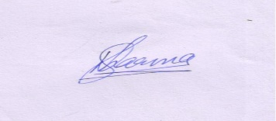

Signature Signature

(Major Chandrakanth Nair) (Manfest-Varchasva)

